Woodward Park
2017 Girls Gymnastics Team
Competition Leotard Order Information

- CHECK MUST BE IN on/before Friday Nov 4, 2016 such that order can deliver in time for first competition.
- Coach Anna will place the orders together to help save shipping costs.
- Parents can drop off checks to Anna any time on/before Friday Nov 4 during practice times
- Girls should also try to find the following items for a warm up uniform over the leotard;
Please look for Plain Red or Purple
    - shorts or yoga pants, a zip jacket, and gripper socks or slide on shoes

Here is a picture of the leotards;
Ella- Karat Competition Leotard design http://www.gymdigs.com
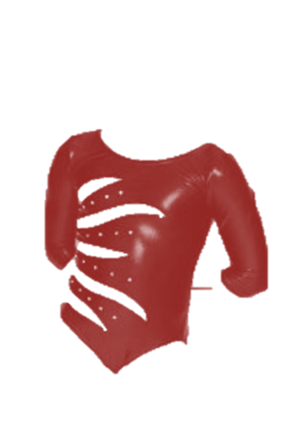

MAKE CHECKS PAYABLE to: GYM DIGS
Because our order is over $100 Shipping is FREE
Base price | $45.00
Add Woodward customization | $24.00
Child sizes | $67.00
Adult sizes | $69.00

This is a great website. Coach Anna has arranged for a leotard fundraiser online.
Think Holiday gifts moms and dads!
There are Biketards, bike shorts and Leotards 5% Gym Digs refund to WP Rec Center Gymnastics with the monies going towards new equipment. (Hopefully a vault; and maybe a small trampoline).

This how to measure for the proper size to order:
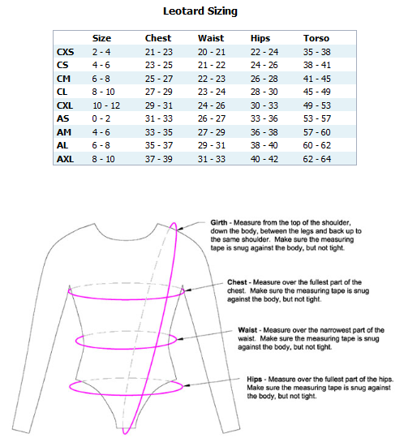

Return this paper with the check:

LEOTARD ORDER FORM:

Gymnast Name:

Gymnast Level: Circle one BRONZE SILVER GOLD

How would you like Coach Anna to contact you if there are any questions?
Phone: Yes, you may text this number
Email:

Size: Check box for size
 | Size
CXS | 2 - 4
CS | 4 - 6
CM | 6 - 8
CL | 8 - 10
CXL | 10 - 12
AS | 0 - 2
AM | 4 - 6
AL | 6 - 8
AXL | 8 - 10

