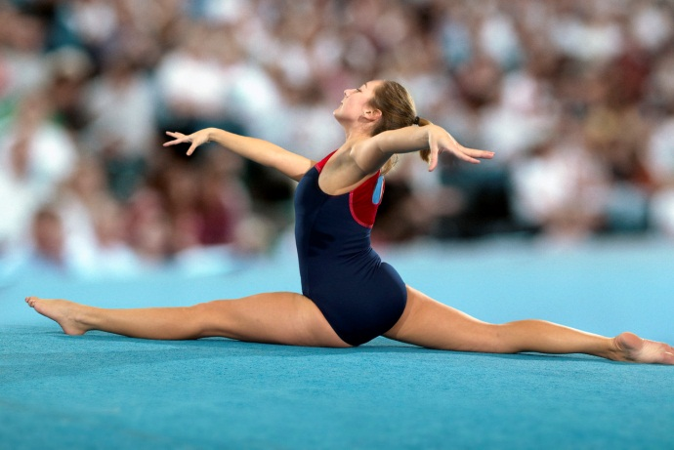
GYMNASTICS BREAK WORK OUT
Warm- up: as much as you can remember
Strength:
- Straddle press
  - 2 x 10 sec with bottom in the air
  - 2 x 10 with feet in the air legs straight
If you can do the hold with feet and bottom up then you only have to do 2 x 10 sec
- Pike press
  - 2 x 10 sec with bottom in the air
  - 2 x 10 with feet in the air legs straight
  - If you can do the hold with feet and bottom up then you only have to do 2 x 10 sec
- Hand stand Shoulder touches
  - 3 touches each shoulder x 2
- Hollow crunches
  - 2 x 25
- Push Ups
  - 2 x 10
- Tight arc rockers
  - 2 x 25
- Swimmers
  - 2 x 25
- Leg swings
  - 2 x 10 right leg each direction ( fwd, bwd, straddle swing / 2 x left leg fwd, bwd, straddle swing
  - 2 x 10 lying on your stomach and leg swing up and back

Good basics:
- Heel turn: 5 x 2 half turns one right after the other
- Full turn on toe 10 turns
- Step-Kick- Lever Lunge HS –Lever Lunge: x 10
- Side X cartwheels: 5 on each side

Flexibility:
- Elbow bridges with feet on something that won’t move 3 for 15 sec
- Pike stick stretch (Put a stick under your foot and pull on it)
  - Feet flexed/legs very straight, back as flat as you can 3 for 15
- Lunge splits with back leg bent straight up – Each Side 2 x 1:00 minute
- Straddle splits with elbows on floor 2 x 1:00 minute

