2017 Columbus City Parks & Rec

Meet Schedule

* **All meets are at Franklin Park**
* **Report Times for every event**
* **Arrive by 8:30 am**
* **Be undressed and ready to begin warm-up with Coach Kristen (Coach Anna does not attend)**
* **All meets except one –Arrive Exactly at 8:30am**
* **Should you need to contact Coach Kristen email:** coachthatcares@gmail.com

**Changes!!**

~~Saturday, December 17th~~

~~Saturday, January 21rd~~

(Woodward Park Assigned Concessions)

~~Saturday, February 11th~~

Saturday, April 1st **- Arrive by 8:30 am**

**April 15th –** Arrive by **NOON** Start time(in place of 2/11/17)

Saturday, May 6th **- Arrive by 8:30 am**

Does your gymnast (Level Silver and above) have their music emailed to coachthatcares@gmail.com, or on Kristen’s phone?

* + **GOLD Team - Tendi, Brooke, Marcella & Lashawnna;** Need to have their music on a disc and emailed to (coachthatcares@gmail.com) by Nov 4th, 2016. The girls have been asked for the last 3 months to find a 0:45-1:00 section of music for their routine –

**ABSOLUTELY NO WORDS, NO HUMMING, or nor ANY OTHER TYPE OF VOCALS ALLOWED**

**Meet Day**

✓**check list**

* Team warm up over team leotard
  + - * Under garment should match Leo color or match complexion
* Hair must be pulled up in any style so hair cannot reach the eyes

Including no floppy long pony tail

* + - * Nor get in the way when rolling backwards.
* Socks with grippers or slip on shoes (to keep their feet clean)
  + - * Even in warm months gymnasts should have foot wear
* Water bottle with water ONLY and small healthy snack in any easy to carry bag
* Grips if you own a pair
* Concentration Book with words

**~~NEED VOLUNTEERS from each Family!! JANUARY 21~~~~st~~ ~~8:15am -NOON /1:00pm~~**

~~Each team can earn funds by sharing some of the extra jobs at the meet they are assigned. Concession/Admissions positions are shared by each center. Our date is for WP is~~ **~~JAN 21, 2015~~**~~. Our team will receive 20% of the money received, please have one person to represent your gymnast available to during the session to help out. Each family should bring something to sell. (Baked goods, fruits snacks, candy, energy bars, water/juice boxes). Training Team is encouraged to help as they also will benefit from the monies.~~

~~Parents can work together to make sure everyone can watch the routines important to them.~~

**Contact person for questions about meet times or weather delays:**

Bryana A. Ross

*Recreation Center Manager*

Holton Recreation Center

303 N. Eureka Avenue

Columbus, OH 43204

(614) 645-3208 [www.columbusrecparks.com](http://www.columbusrecparks.com/)

ALL MEETS are held at the following;

**Franklin Park**

1755 E Broad Street, Columbus, OH 43203

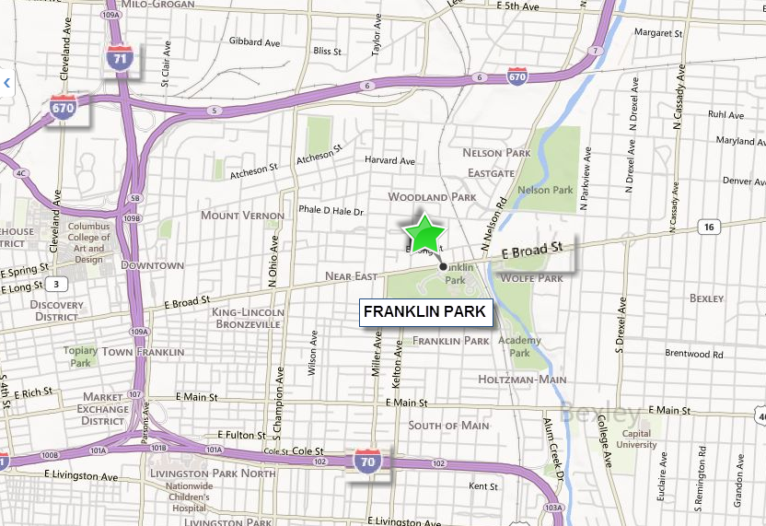

Scan image with phone to map:

